**ANSIBLE PROGRAM DOCUMENTATION**

**Problem Definition**:  
An Ansible module that fetches a zip file from a web location and extracts a config file from it.   
  
**Ansible module expected workflow**:  
1. Ansible module downloads the ‘ansible.zip’ file from the specified location. The file could be stored on online repositories such as Dropbox, Google Drive, GitHub etc. and services can provide direct download links to the stored files.   
2. Ansible module unzips the downloaded archive to a location on the disk.   
3. The extracted file is copied over to the new location on the disk.

**Development Environment**:   
Python has been used for developing the custom Ansible module on Windows platform. Cygwin libraries were utilized to simulate the Linux functionality on Windows and create a virtual environment to install Ansible and its dependencies on the platform.   
  
**Code Documentation**:  
‘AnsibleProgram.py’ includes the code logic using Ansible module for downloading, extracting and copying the unzipped file to desired location. This script takes arguments from the ‘arguments.json’ json file.   
‘AnsibleProgram.py’: This file includes the following functions:   
 - ***main()***: This is the first function to be invoked inside the script. This defines the structure of all the input parameters received from the json file into module arguments. This function also defines the output variables to be displayed by the module.   
Input parameters: The Ansible module receives arguments from the external ‘arguments.json’ file. ‘name’ describes the name of the module being run, ‘url’ describes the download URL link to the zip file, ‘message’ describes an optional message that be passed on to the Ansible module, ‘success’ describes the success/failure status o the entire logic.  
 - **DownloadZip()**: This function is invoked by the main() function. It defines the variables that point to the directories where the zip file will be downloaded and extracted to. The main logic within this function is to invoke a webrequest using the URL that points to the online location where the ansible.zip file is stored. The response obtained is then written down to generate a zip file at the desired location.   
Input parameters: ‘result’ dictionary that includes variables to output to Ansible module for checking the success/errors/messages of the program. ‘module’ that takes in arguments passed to Ansible module.   
 - **ExtractZipandCopyToDir():** This function is invoked by the DownloadZip() function. The primary functionality offered by this function is to extract the zip file from the downloaded archive on the disk into a folder and copy the unzipped archive.config file from the folder to ‘export’ directory and the source directory and zip file are removed.  
Input parameters: ‘result’ dictionary that includes variables to output to Ansible module for checking the success/errors/messages of the program. ‘module’ that takes in arguments passed to Ansible module. ‘zipfilepath’ and ‘zipfileextractdir’ variables respectively point to the downloaded archive file and the directory to extract the archive’s contents to.  
  
**Program tests and snapshots**:   
Please refer to the ‘AnsibleTests.docx file for tests and supporting snapshots.  
  
  
  
  
**Test run:**Module is executed from the following command line input:   
***python AnsibleProgram.py args.json***  
***Url Link***: <https://raw.githubusercontent.com/GauravPurohit/AnsibleTestRepo/master/ansible.zip>  
The code logic locates the ansible.zip file on the online service repository using the URL specified.   
In this example, I’ve used stored the archive on my GitHub repo:  
  
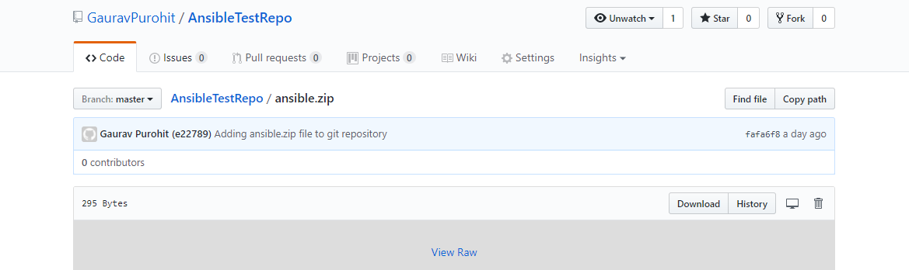   
  
This archive file is then downloaded to the specified location (comments added beside the location in pyScript) and extracted to a local directory from that location. From here, the content is moved over to the ‘exports’ folder and the downloaded archive file and the directory to which archive’s contents were previously extracted to, are removed.   
  
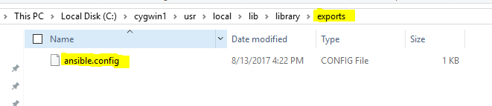  
  
  
  
  
  
  
  
  
  
  
  
  
  
  
  
  
  
  
Similarly, ansible.zip can be downloaded from my Google drive:   
  
***Url Link***: https://drive.google.com/uc?export=download&id=0B326NJlpA7W7VEZNQnNrUHhDYms  
  
